Data Structure Related important points to remember: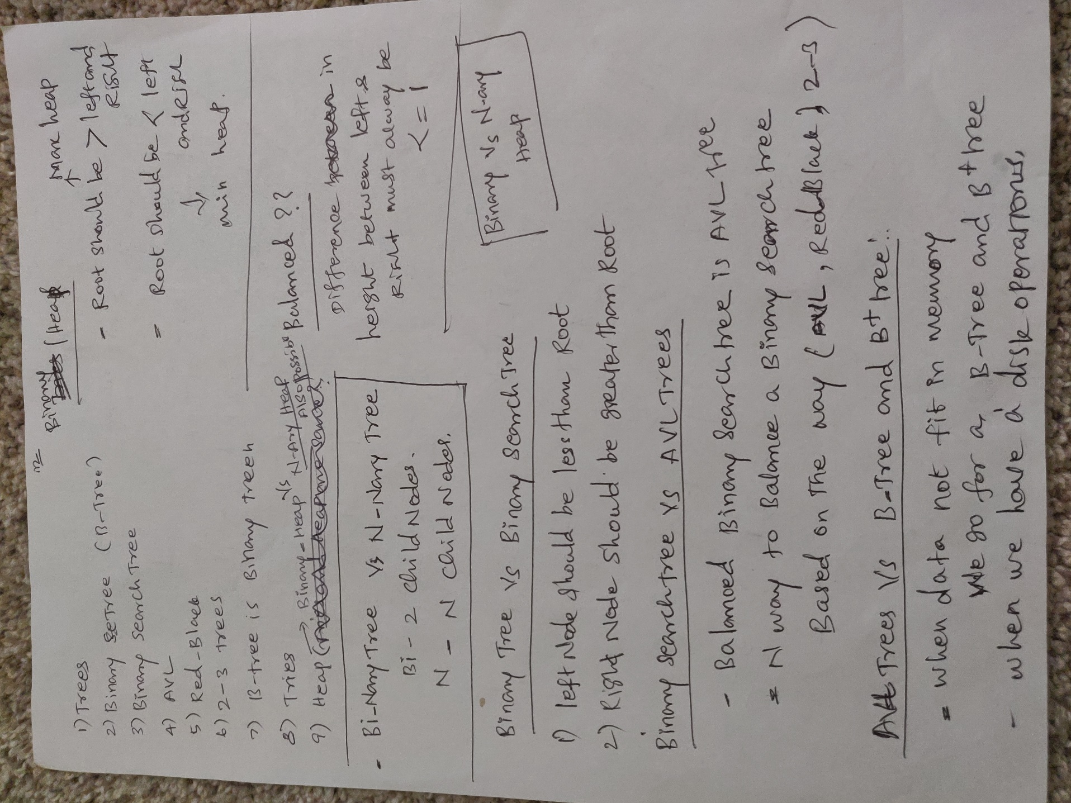

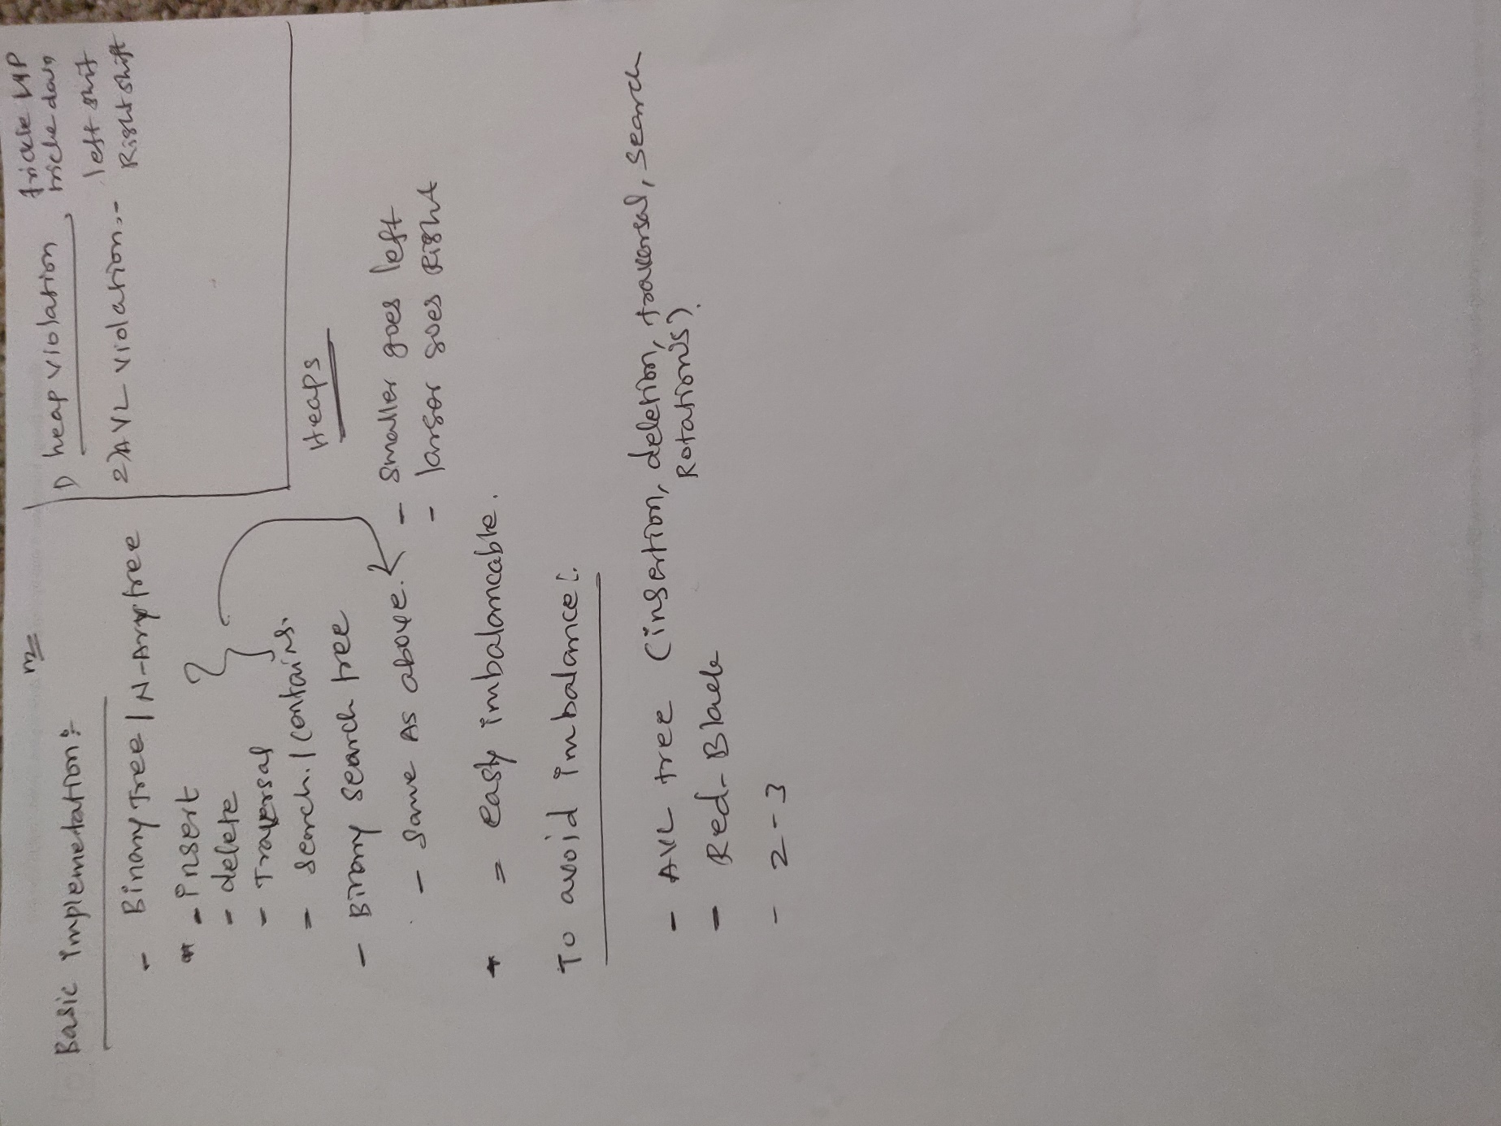

Tree:

Removing a Node:

1. If we are removing leaf node set it’s parent to NULL.
2. If we are removing a parent with one child, set it’s parent to point to it’s child.
3. If we are removing a parent node with two child, SWAP them with In-order Successor or Predecessor and remove the leaf node.

In-order successor 🡪 go to left and all the way to right.

In-order predecessor 🡪 Go left and all the way to left.

Rotation:

Balanced vs Not Balanced:

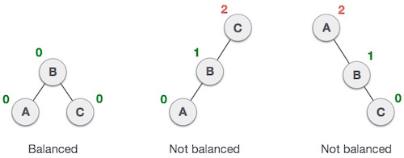

***BalanceFactor*** = height(left-sutree) − height(right-sutree)

***BalanceFactor*** <= 1

* Left rotation
* Right rotation
* Left-Right rotation
* Right-Left rotation

Left Rotation

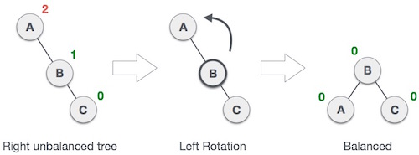

Right Rotation

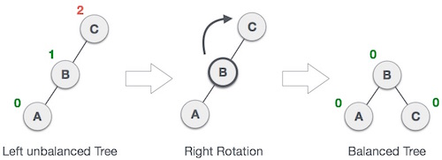

Left – Right Rotation

* Left rotate the parent
* Right rotate the grand parent

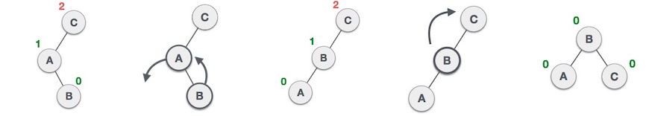

Right – Left Rotation

* Right rotate the parent
* Left rotate the grand parent

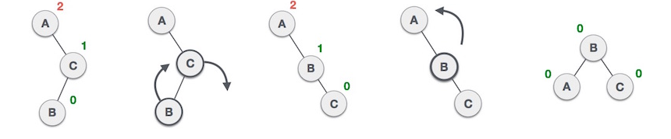

Checking Binary Tree Balance:

